Python Class 3/26/20

* Functions start with a def x(name): # name is called a parameter
  + List a function for example – print(f”dfsdngfsdhgnafk {name}”)

You can have a second parameter, just separate it by a comma. You can mke the parameter name=tom. The function will always assume the name is Tom unless you specify

* X(Tom): # Tom is called an argument

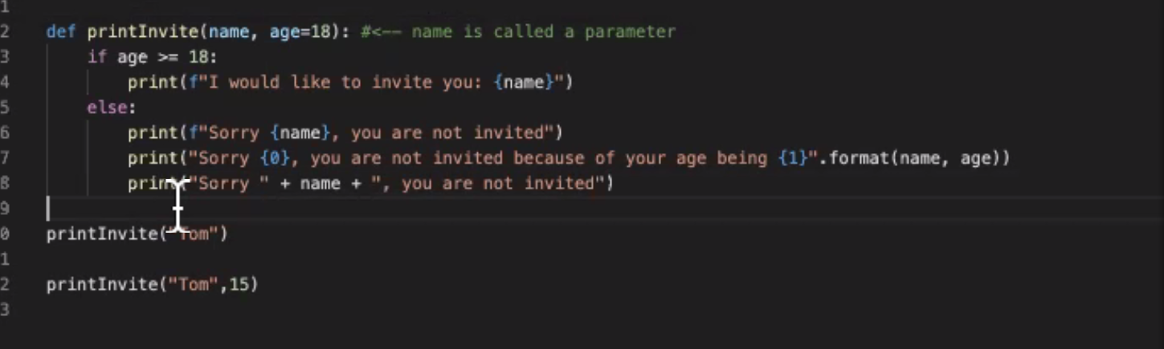

Git.ignore will let you upload sheets and tell it not to update certain sheets

